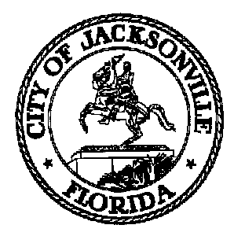

JACKSONVILLE CITY COUNCIL
RESEARCH DIVISION

Noticed Meeting CM Boyer-Danford Neighborhood Bill of Rights
Meeting Minutes

April 12, 2019
9:00 am

Don Davis Room
First Floor, City Hall
117 W. Duval Street

Topic: CM Boyer-Danford re Neighborhood Bill of Rights

Attendance: Council Member Boyer; Richard Danford – Community Engagement Subcommittee Chair; Colleen Hampsey – Council Research; Crystal Shemwell – Legislative Services

For all other attendees please see the sign in sheet

Meeting Convened: 9:00 am

This was a meeting between Council Member Boyer and Richard Danford, Chair of the Community Engagement Subcommittee to discuss Ordinance 95-247-106 which established the Neighborhood Bill of Rights. CM Boyer explained that the ordinance was approved by council but not codified, and is therefore not implemented or enforceable. One finding of the 2014 Consolidation Task Force was that all ordinances should be codified.

However, CM Boyer pointed out that while the spirit of the Neighborhood Bill of Rights is relevant, the language used is outdated and not in keeping with modern technology. For example, the 1995 ordinance states that questions from the public regarding City Business should be answered within one business day – which is not always practical. Additionally, the ordinance was written before the use of email was commonplace. Dr. Danford said that there needs to be some formal process established so that members of the public feel that they have a way to have their viewpoints or issues heard by City officials.

There was a discussion about how the public may communicate with City officials and departments. Currently Neighborhood Associations, through CPACs, can make recommendations on CIP projects and the budget. However, Dr. Danford said that many portions of the community feels disconnected from local government despite the availability of CPACs. It was mentioned that there is not enough public awareness about CPACs.

CM Boyer said that there are existing processes for public communication, but those processes may not be well known. It was suggested that holding regular town hall meetings or listening sessions might provide a better venue for communication, as people may not always like the outcomes from City decisions but they like to feel heard. Dr. Danford proposed that his subcommittee review the 1995 ordinance, find which portions are effective, update it as needed and submit it to City Council.

With no further business, Mr. Munz adjourned the meeting. The next collaborative subcommittee meeting will be Friday April 12, 2019 at 2:00 pm.

Meeting Adjourned: 9:40 am

Minutes: Colleen Hampsey, Council Research
CHampsey @coj.net (904) 630-1498
Posted 4.16.19 5:00 pm

Tape: CM Boyer-Danford re Neighborhood Bill of Rights
Meeting - Legislative Services Division
4.12.19

